# **Erum Sikander Sunday 2 to 5 pm**

# **Hackathone-3 Day 4**

**Implementation Report**

**Product 1, 2, 3 Listing and Dynamic Routing:**



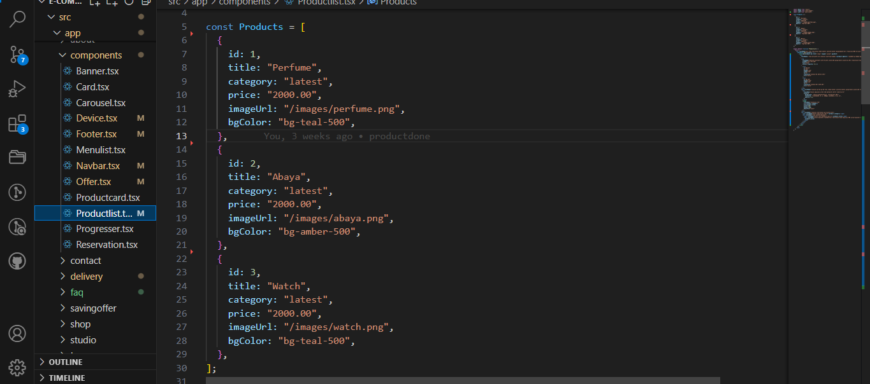

**Product 4, 5, 6 Listing and Dynamic Routing:**



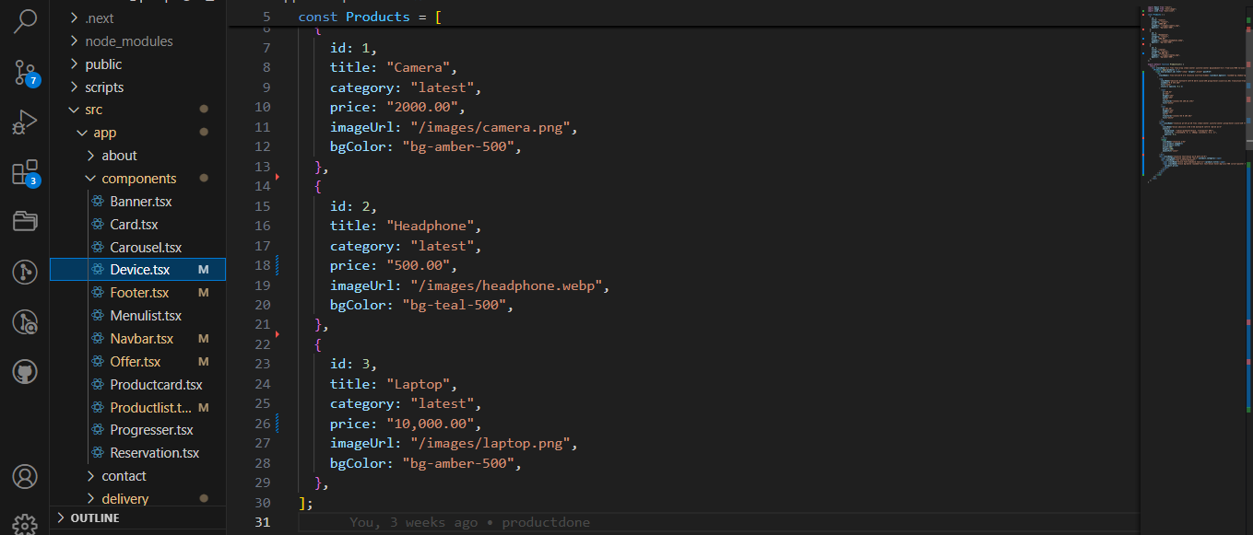

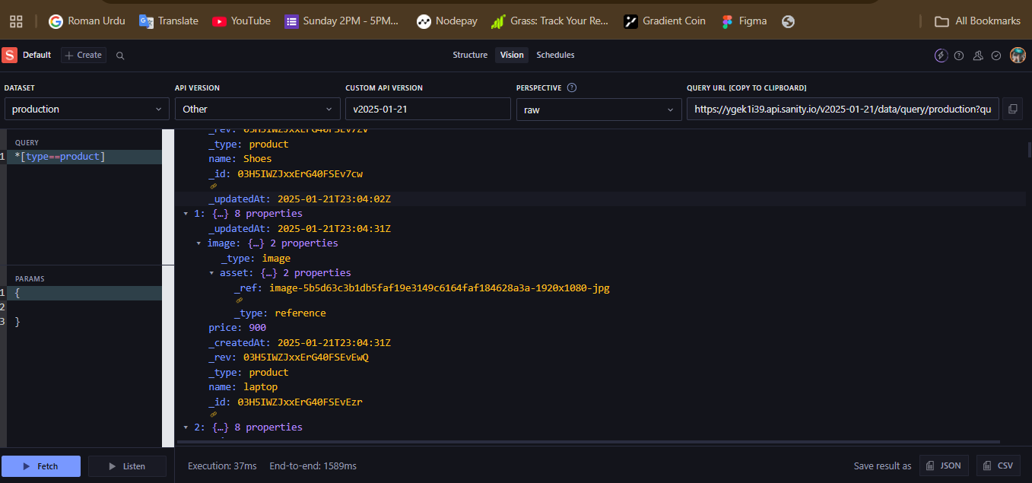

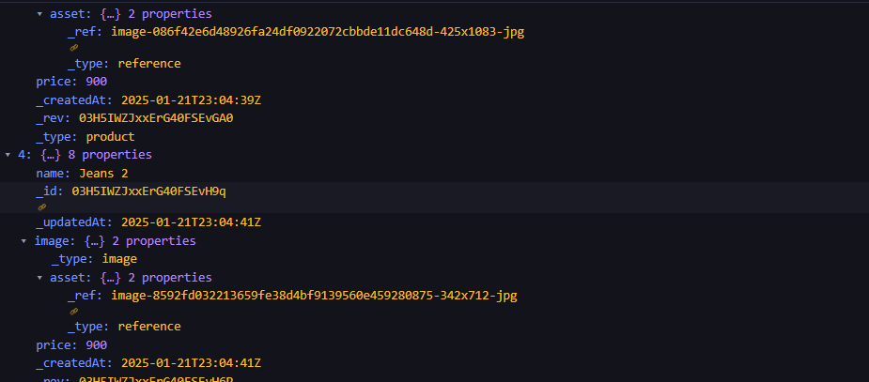

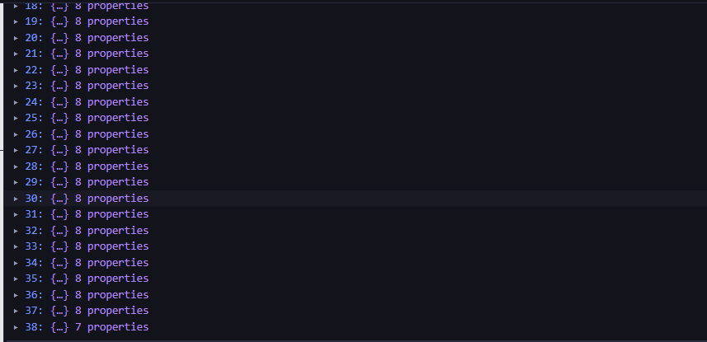

Your obedient student,

Erum Sikander

Sunday 2 to 5 pm (Senior Student)